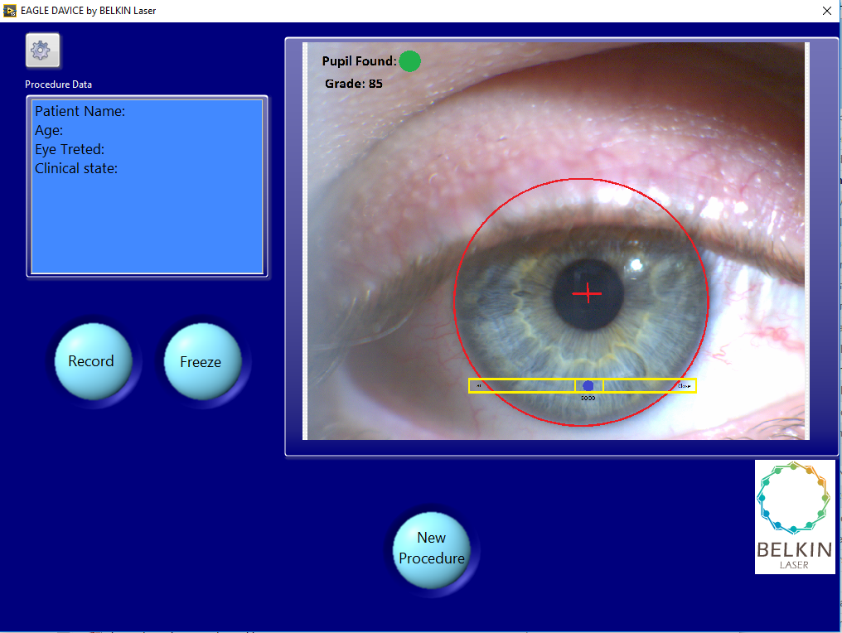

Changes: Starting Process:

* Enter the Patient Data.
* Set the correct parameters per patina ------איזה נתונים אנו יכולים לשנות מבחינת עוצמות תדרים וכולי?
* Canter the red cross on the Pupil.
* Set the red cross to get clear aye picture (Focus)
* Verify centering yellow on Limbus
* Verify red circle (treatment region) are clear
* Start the lasing process
* For second process act according all above.

1. Central cross to roughly align pupil
2. Yellow boxes on SW limbus
3. Spelling: device, treated,
4. Add tags to shapes: red circle – treatment region, yellow rectangles – ranging beams

“Focusing Beams” is clearer

1. Patient name → Patient Number
2. Age – not required
3. What do you mean “clinical state”?
4. Buttons: “Begin New Procedure”
5. When recording – the Record button should be red

Some examples for screens in ophthalmic devices:

It seems that when an image of the eye is on screen – a black background is used.

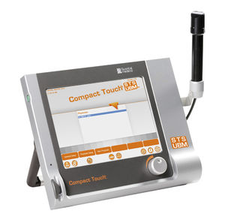

|  |  |
| --- | --- |
|  |  |

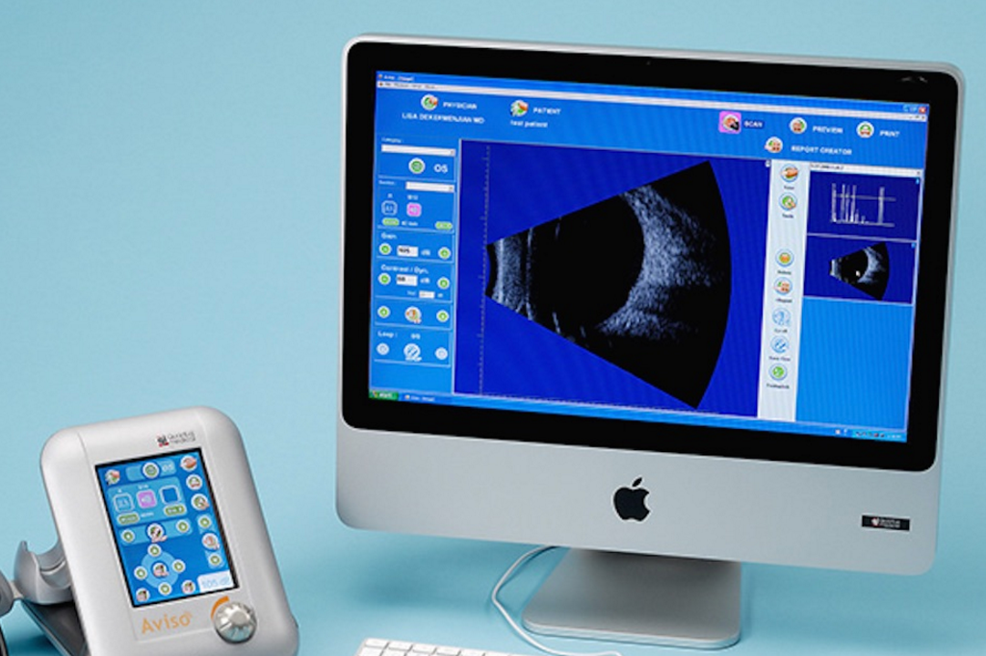

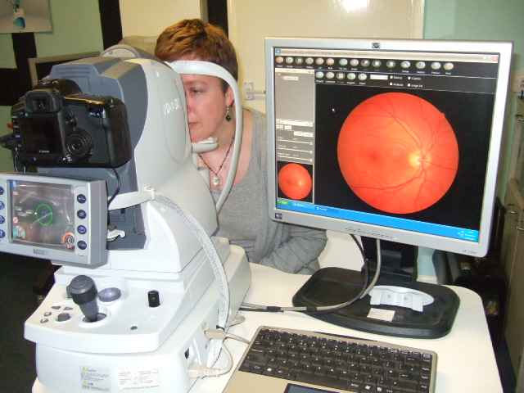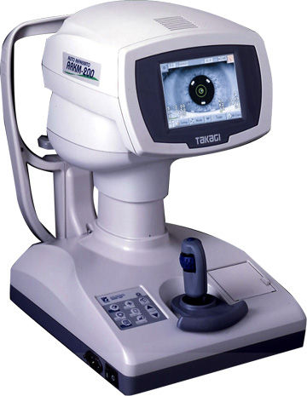

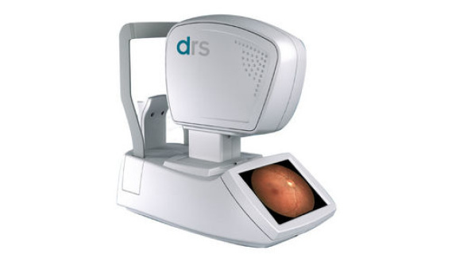 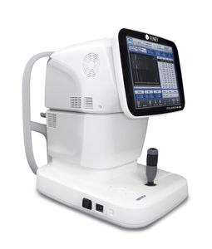

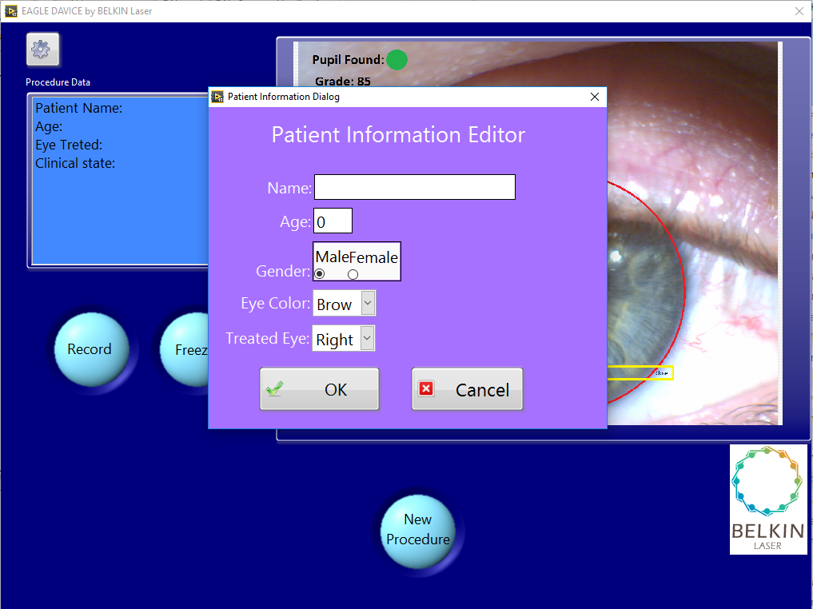

No need to elaborate on patient. Only number. All other info is in the patient’s file.

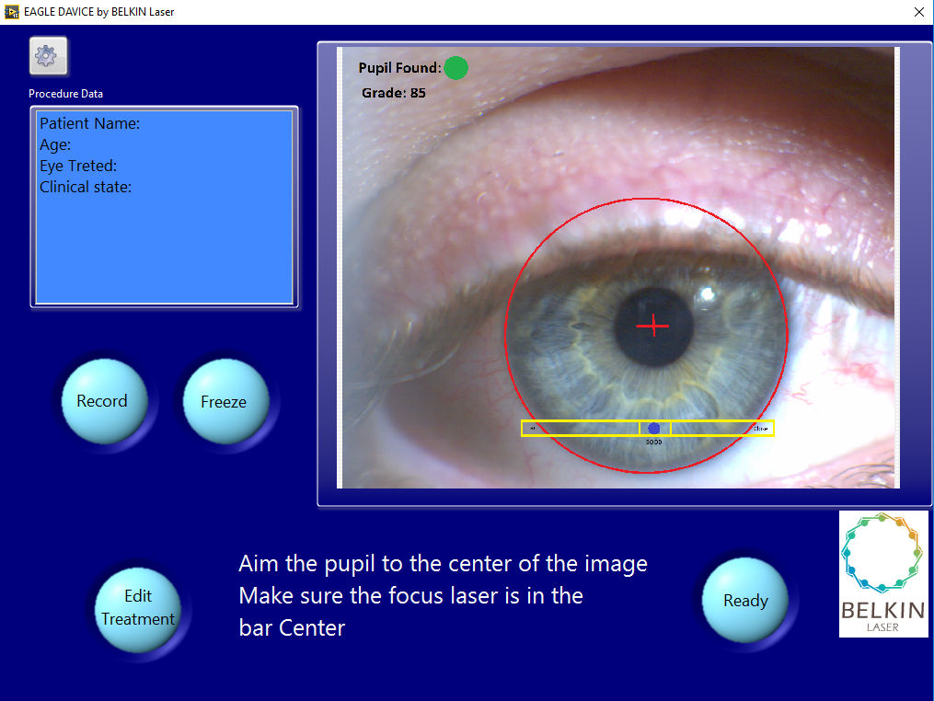

1. Step 1: “Align cross ~~hairs~~ to center of pupil”. When software agrees that it is aligned, then light the triangulation beams.
2. Step 2: “Overlap ~~ranging~~  Focus Beams to ~~edge of limbus~~ the yellow square (~~treatment point~~).

“Note: you may move pupil slightly off center of cross.”

When software agrees that it is aligned, then light treatment aiming beam.

1. Step 3: “Verify treatment zone (red circle) by pushing the “Ready” button or ~~change~~ Edit Treatment” The other devices use “Standby” buttons instead of “ready”.
2. Step 4: push the “Treat” button.

The Treat button should be on the same screen, after pressing the Ready Button

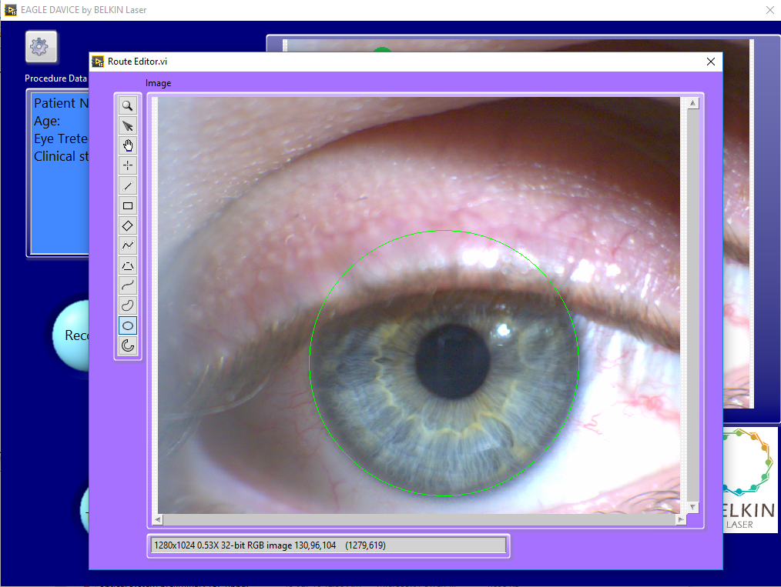

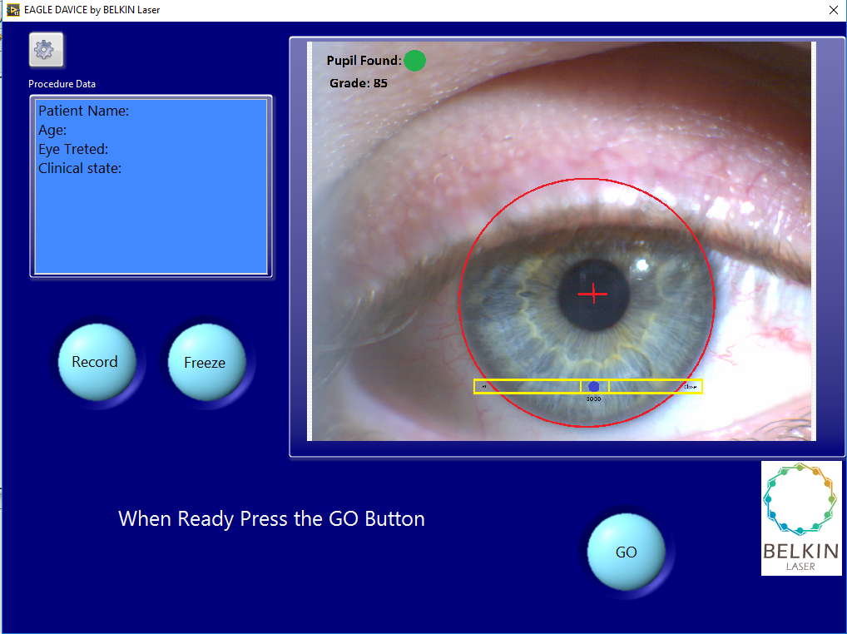

This screen is מיותר

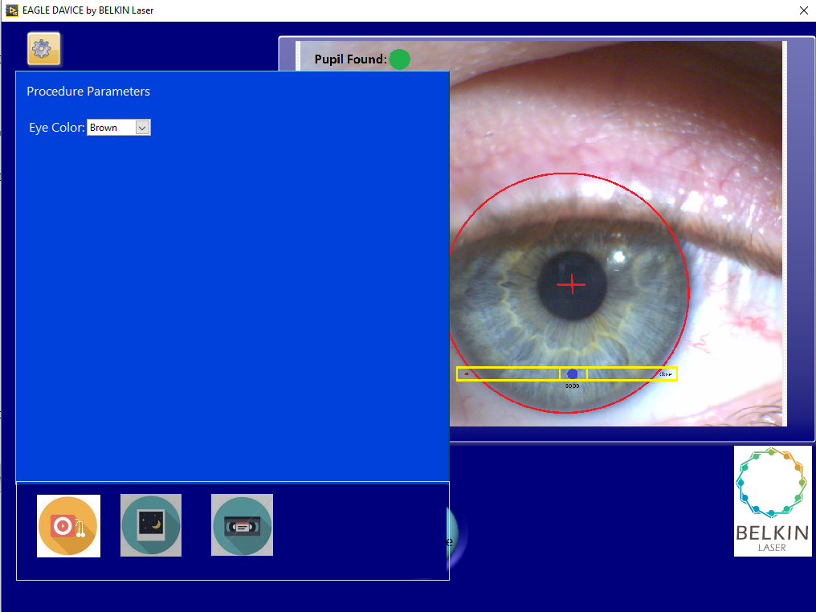

By Pressing here this service panel opens

One service screen is sufficient for service

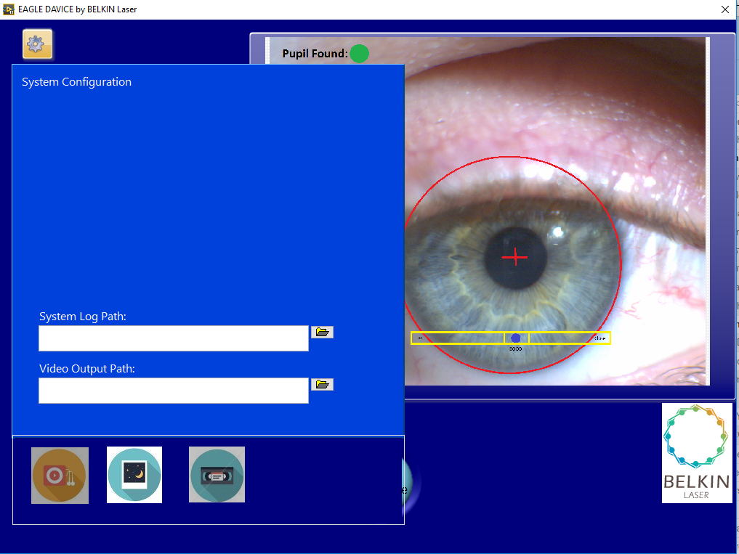

Selection of active sub panel. (Icons are only for example)